INSTRUCTIONS:
- Save a headshot of yourself on your desktop
- Right click on the square headshot pictured below and choose “Change Picture”
- Find the picture you saved of yourself on your computer and choose that and click “Insert”
- Change the text that says “Your Name” to your first and last name
- Change the text that says “MM112233445” to your Drivers License Number
- Print and cut out or fold your badge for display in your vehicle

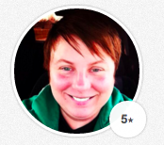
Your Name

MM112233445

